Design Phase
1. Overview
The Design phase focused on developing a scalable, modular, and efficient architecture for an AI-powered illegal dumping detection system. The system was designed to operate in real time, process CCTV video streams, and generate actionable insights through an integrated dashboard.
Key design objectives included:
- achieving real-time performance (15–30 FPS)
- maintaining high detection accuracy (≥80%)
- ensuring scalability and modularity
- addressing hardware and data constraints

2. System Architecture Design
The system adopts a multi-layered architecture, separating concerns across different components to improve maintainability and scalability.
AI Processing Layer
This layer handles video analysis and consists of:
- motion detection
- object tracking
- classification (MobileNetV3)
This staged approach enables the system to first detect movement, then track objects, and finally classify them, improving detection reliability.
Event Processing Layer
Once an object is classified as waste, an event is generated containing:
- timestamp
- confidence score
- object type
This structured representation ensures consistent data handling across the system.
Backend Layer
The backend (Flask-based) manages:
- API communication (JSON)
- event processing and streaming
- integration between system components
Data Storage Layer
A database is used to store:
- detected events
- logs
This enables historical analysis and system monitoring.
Presentation Layer
A Streamlit-based dashboard provides:
- real-time alerts
- data visualisation (charts, trends)
- GIS-based mapping
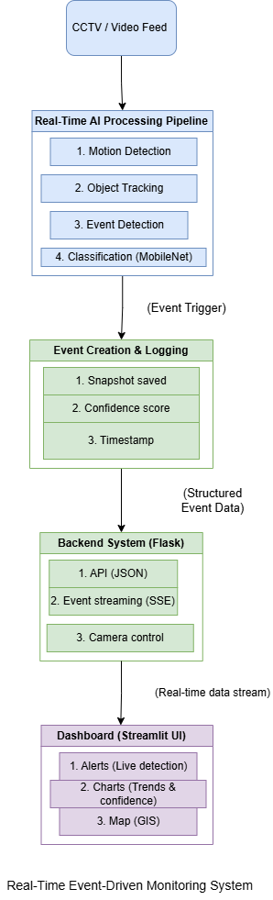
3. Data Flow and System Behaviour
The system operates as a continuous real-time pipeline, as illustrated in the control and data flow diagrams.
Data Flow:
- CCTV cameras provide video frames
- Frames are processed through the AI pipeline
- Detected waste events are converted into structured data
- Data is sent to the backend via API
- Events are stored in the database
- The dashboard retrieves and displays data
Control Logic:
- The system continuously processes frames in a loop
- Detection is triggered only when motion is detected
- Objects must remain stationary before classification
- Events are generated only when waste is confirmed
This design reduces false positives and improves efficiency.
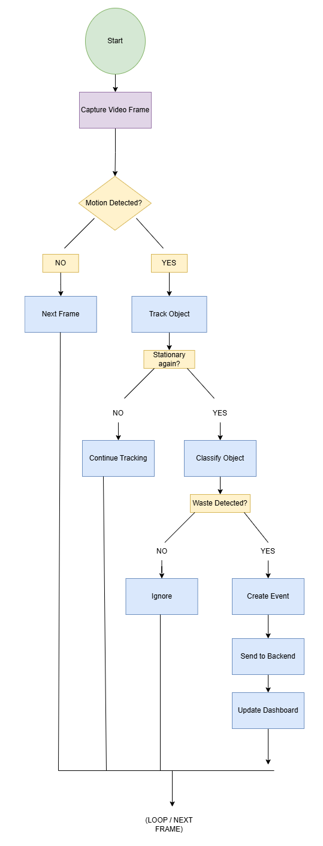
4. Model Design and Selection
A Convolutional Neural Network (CNN) was used for classification, specifically MobileNetV3.
Justification:
- lightweight architecture suitable for real-time systems
- lower computational requirements compared to ResNet/EfficientNet
- faster inference speed
Trade-Off:
- slightly lower accuracy compared to deeper models
- significantly improved performance and efficiency
To address data limitations, the model was enhanced using:
- transfer learning
- data augmentation
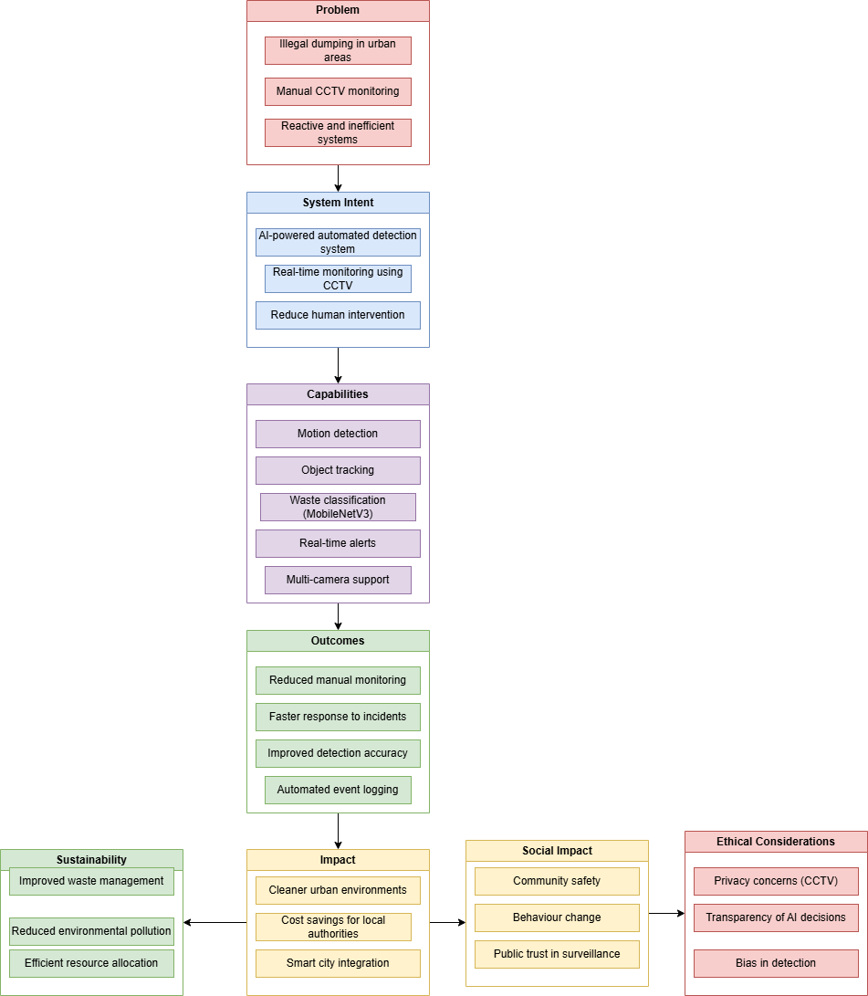
5. Technology Stack Justification
Component | Technology | Justification
Programming | Python | Strong support for AI and computer vision
Video Processing | OpenCV | Efficient frame processing and motion detection
AI Framework | TensorFlow / PyTorch | Industry-standard deep learning tools
Backend | Flask | Lightweight and suitable for real-time APIs
Frontend | Streamlit | Rapid development of interactive dashboards
These technologies were selected to balance performance, simplicity, and scalability.

6. Design Decisions and Trade-Offs
Several key design decisions were made:
Accuracy vs Performance
- High-complexity models were rejected due to latency
- MobileNetV3 selected to ensure real-time processing
Real-Time Processing vs System Complexity
- A multi-stage pipeline was used instead of a single model
- improves reliability but increases system complexity
Local vs Cloud Processing
- Local processing used for prototype
- cloud deployment considered for scalability
Simplicity vs Scalability
- modular architecture allows future expansion

7. Constraints and Limitations
The design was influenced by several constraints:
🔹 Hardware Constraints
- limited GPU availability
→ required lightweight models
🔹 Data Limitations
- limited labelled dataset
→ addressed using augmentation and transfer learning
🔹 Real-Time Requirements
- strict latency constraints
→ optimisation of processing pipeline

8. Ethical and Regulatory Considerations
Ethical principles were incorporated into the system design:
- Privacy by design: no facial recognition used
- Data minimisation: only relevant event data stored
- Transparency: event logging enables traceability
The system was designed to align with:
- GDPR
- data protection principles

9. Performance Requirements
The system was designed to meet the following targets:
- Accuracy: ≥ 80%
- Processing speed: 15–30 FPS
- Latency: < 200 ms
These requirements ensure practical usability in real-world environments.

10. Design Validation Strategy
To validate the design, the following approaches were used:
- testing across multiple environmental conditions
- evaluation of model accuracy and performance
- integration testing of system components
- stakeholder feedback on usability

11. Summary
The Design phase demonstrates:
- a modular and scalable system architecture
- strong technical justification and trade-off analysis
- effective handling of constraints and real-time requirements
- integration of ethical and regulatory considerations
Overall, the design provides a robust foundation for a commercially viable, real-time AI monitoring system.

